- Add following 4 dependencies in pom.xml
<dependency>
<groupId>org.springframework.boot</groupId>
<artifactId>spring-boot-starter-security</artifactId>
</dependency>

<dependency>
<groupId>io.jsonwebtoken</groupId>
<artifactId>jjwt-api</artifactId>
<version>0.11.5</version>
</dependency>

<dependency>
<groupId>io.jsonwebtoken</groupId>
<artifactId>jjwt-impl</artifactId>
<version>0.11.5</version>
<scope>runtime</scope>
</dependency>

<dependency>
<groupId>io.jsonwebtoken</groupId>
<artifactId>jjwt-jackson</artifactId>
<version>0.11.5</version>
<scope>runtime</scope>
</dependency>

- Create enums package and in that package create Role.java class
public enum Role {
CUSTOMER, ADMIN
}

- In models package, create User.java class as –
@Data
@Entity
public class User {
@Id
@GeneratedValue(strategy = GenerationType.IDENTITY)
private long id;

private String fullName;

private String email;

private String password;

private String address;

private String pincode;

@Enumerated(EnumType.STRING)
private Role role;

}

- In repositories package create UserRepository.java interface as
@Repository
public interface UserRepository extends JpaRepository<User, Long>
{
//to get user details by email while login
Optional<User> findByEmail(String email);
//to check if email already exist while registration
boolean existsByEmail(String email);
}

- Create daos package and in that package create RegisterUser.java and LoginUser.java classes
@Data
public class UserRegister {
private String email;
private String password;
private Role role;
}

@Data
public class UserLogin {
private String email;
private String password;

}

- In services package create UserService.java class
@Service
public class UserService {
@Autowired
PasswordEncoder passwordEncoder;

@Autowired
MyResponseWrapper responseWrapper;

@Autowired
UserRepository userRepository;
private ResponseEntity<?> universalResponse(String message, Object data, HttpStatus httpStatus)
{
responseWrapper.setMessage(message);
responseWrapper.setData(data);
return new ResponseEntity<> (responseWrapper,httpStatus);
}

public ResponseEntity<?> register(UserRegister userRegister)
{
if(userRepository.existsByEmail(userRegister.getEmail()))
{
return universalResponse("Email Exists",null, HttpStatus.INTERNAL_SERVER_ERROR);
}
User newUser = new User();
newUser.setEmail(userRegister.getEmail());
newUser.setPassword(passwordEncoder.encode(userRegister.getPassword()));
newUser.setRole(userRegister.getRole());
User registeredUser=userRepository.save(newUser);
return universalResponse("Registration Success!",registeredUser, HttpStatus.CREATED);
}

}

- In controllers package create UserController.java as –
@RestController
@RequestMapping("/api/v1")
public class UserController
{
@Autowired
UserService userService;

@PostMapping("/register")
public ResponseEntity<?> register(@RequestBody UserRegister userRegister)
{
return userService.register(userRegister);
}

}

- In configurations package, create SecurityConfiguration class as –
@Configuration
@EnableWebSecurity
public class SecurityConfiguration {

@Bean
SecurityFilterChain securityFilterChain(HttpSecurity httpSecurity) throws Exception
{
return httpSecurity
.csrf(anyRequest -> anyRequest.disable())
.authorizeHttpRequests(request ->
{
request
.requestMatchers("/api/v1/login", "/api/v1/register").permitAll()
.anyRequest().authenticated();
})
.build();
}

@Bean
PasswordEncoder myPasswordEncoder()
{
return new BCryptPasswordEncoder();
}
}

- Check on postman
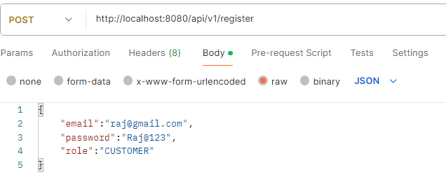
- DONE REGISTRATION

